Crack Analysis:

Test with circular cracking:

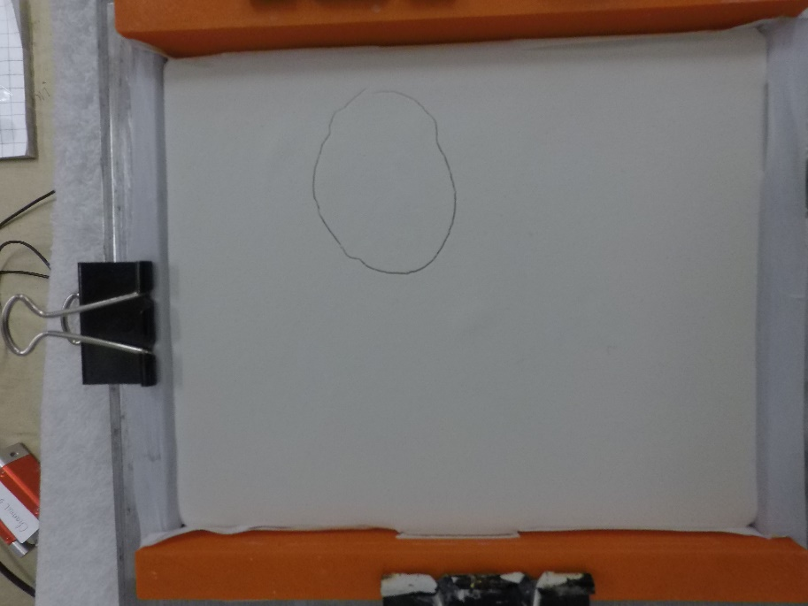

Cropped Image:

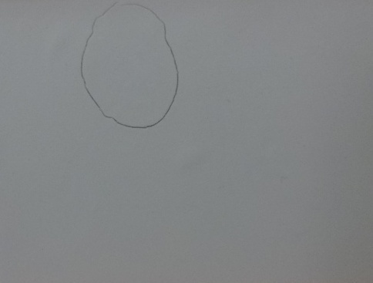

Canny Edge Detection:



Final Image highlighting added length:

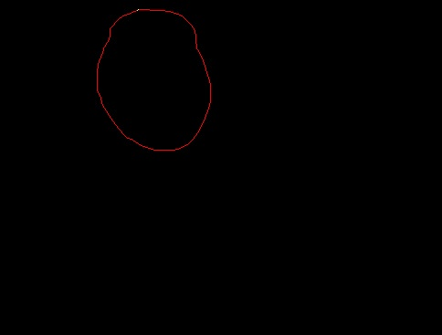

Output:

Length 1 (Red): 9.850 inches

Testing with a variable width:



Canny Edge Detection:

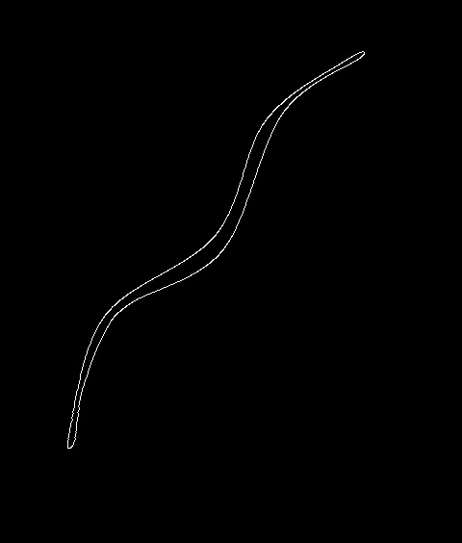

Final Image highlighting added length:



Slopes:

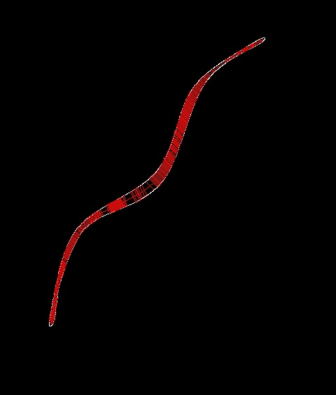

Output:

Length 1 (Red): 11.899 inches